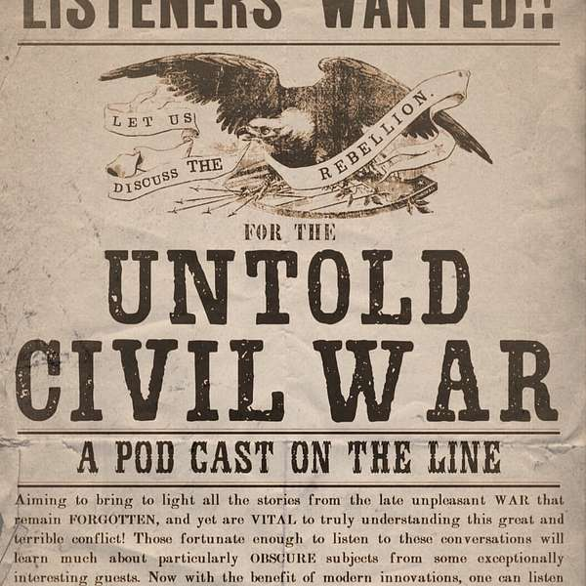
I was featured in a podcast that aims to bring to light all the stories of the Civil War that remain forgotten and yet are vital to our understanding of the conflict.

https://www.buzzsprout.com/796715/episodes

